Race-Day system ERD:
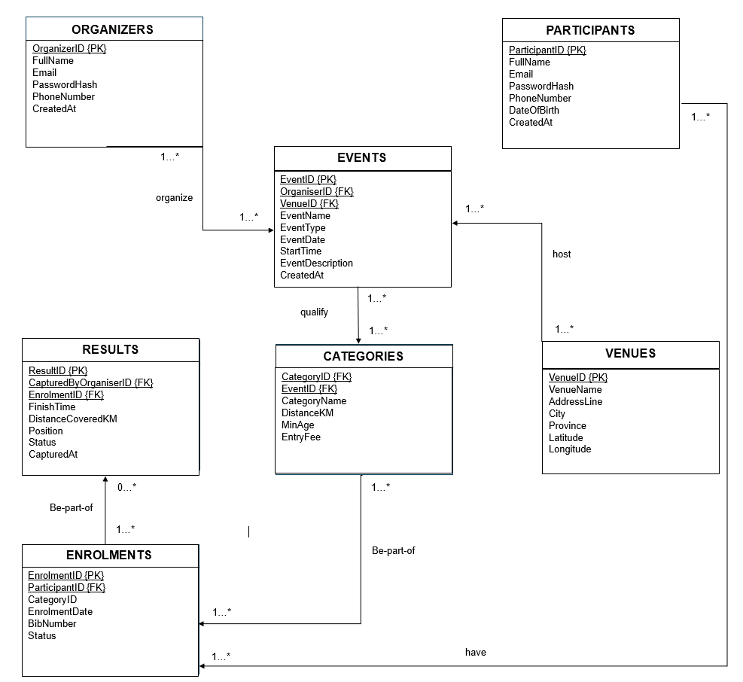

ERD Explanation:

The above entity relationship diagram for the database that is going to be used in the Race-Day system. It has 7 entities, representing 7 tables and each has multiple attributes. The attributes namely:
- Organizers which is to store the information of the administrators/organizers of the events to be registered/added on the application
- Events, to store the information of said events e.g Tour of Cape Town;
- Participants, to store the information of the participants using the application to enrol for different events and track their progress;
- Venues to store the information of the different venues where these events will be hosted;
- Categories to store what category each event fall under/what type of event it is, for example, Running, Cycling, etc.
- Results to store the detailed results of each racing event at the end
- Enrolment to store the details of what event each participant enrols into

Relationships between entities:
One to many organizers can organize one to many events
One to many events can qualify for one to many categories
One to many participants can have one to many enrolments
One to many categories can be part of many enrolments
One to many enrolments can be part of zero to many results
One to many venues can host one to many events

